**Git Hub upload new projects on git hub by commands using git bash**

GitHub, Inc. is a provider of Internet hosting for software development and version control using Git. It offers the distributed version control and source code management functionality of Git, plus its own features

Millions of developers and companies build, ship, and maintain their software on GitHub—the largest and most advanced development platform in the world.

[**Parent organization**](https://www.google.com/search?client=firefox-b-d&sa=X&bih=687&biw=1525&hl=en-GB&sxsrf=ALiCzsb8kKYUD1x6mMazisvEL2YJUYTAVQ:1657875309996&q=github+parent+organization&stick=H4sIAAAAAAAAAOPgE-LSz9U3KKosKMhN1zLIKLfST87PyUlNLsnMz9PPL0pPzMusSgRxiq0KEotS80oUkAUXsUqlZ5ZklCYpYJEEACExg9RdAAAA&ved=2ahUKEwiK9rvnwvr4AhUKR2wGHVBaD3YQ6BMoAHoECHAQAg)**:** [**Microsoft Corporation**](https://www.google.com/search?client=firefox-b-d&sa=X&bih=687&biw=1525&hl=en-GB&sxsrf=ALiCzsb8kKYUD1x6mMazisvEL2YJUYTAVQ:1657875309996&q=Microsoft&stick=H4sIAAAAAAAAAOPgE-LSz9U3KKosKMhNV-IAsU2Ky0y0DDLKrfST83NyUpNLMvPz9POL0hPzMqsSQZxiq4LEotS8EgVkwUWsnL6ZyUX5xflpJTtYGXexM3EwAACaMSA4XgAAAA&ved=2ahUKEwiK9rvnwvr4AhUKR2wGHVBaD3YQmxMoAXoECHAQAw)

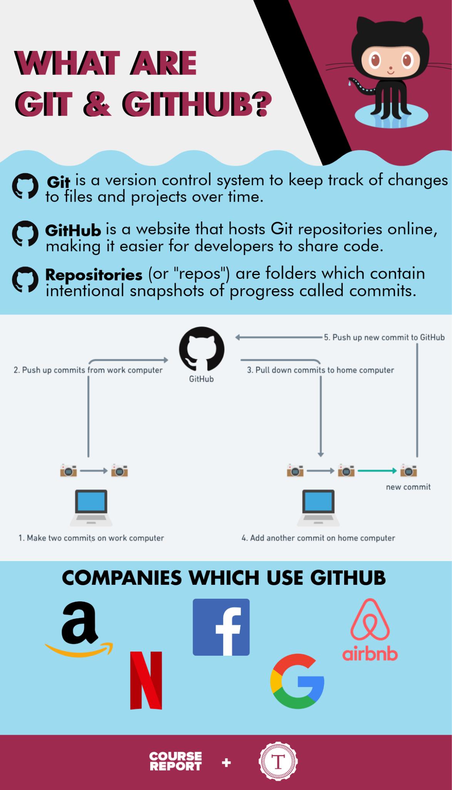

**Using git bash**:self github cli interface for command line

Download git

<https://git-scm.com/download/win>

**Git bash commands**

Brijesh Pandey@DESKTOP-IBTQDCI MINGW64 /g

**$ mkdir testing**

Brijesh Pandey@DESKTOP-IBTQDCI MINGW64 /g

**$ cd testing/**

Brijesh Pandey@DESKTOP-IBTQDCI MINGW64 /g/testing

**$ touch testing.html**

Brijesh Pandey@DESKTOP-IBTQDCI MINGW64 /g/testing

$ dir

**testing.html**

Brijesh Pandey@DESKTOP-IBTQDCI MINGW64 /g/testing

$ notepad testing.html

**cat testing.html**

Brijesh Pandey@DESKTOP-IBTQDCI MINGW64 /g/testing

$ **cat testing.html**

hi my name is brijesh just it for testing

alias brijesh pandey

Brijesh Pandey@DESKTOP-IBTQDCI MINGW64 /g/testing

Check status on git

**$ git status**

Initialised git

**git init**

Check status on git

**$ git status**

On branch master

No commits yet

Untracked files:

(use "git add <file>..." to include in what will be committed)

testing.html

nothing added to commit but untracked files present (use "git add" to track)

Now we add in git

**git add .**

**Now check file is added on master branch or not**

Brijesh Pandey@DESKTOP-IBTQDCI MINGW64 /g/testing (master)

**$ git commit -m 'my first testing file added'**

[master (root-commit) 5946c6e] my first testing file added

1 file changed, 2 insertions(+)

create mode 100644 testing.html

**To check git id**

Brijesh Pandey@DESKTOP-IBTQDCI MINGW64 /g/testing (master)

**$ git log**

commit 5946c6ea031cfb5a8481d02dd3dc3f5a5283f89b (HEAD -> master)

Author: unknown <bkpandey.pandey@gmail.com>

Date: Fri Jul 15 13:12:34 2022 +0530

my first testing file added

**To short our git id**

Brijesh Pandey@DESKTOP-IBTQDCI MINGW64 /g/testing (master)

**$ git log --oneline**

5946c6e (HEAD -> master) my first testing file added

**Add our local file on remote or our server repository**

Brijesh Pandey@DESKTOP-IBTQDCI MINGW64 /g/testing (master)

**$ git remote**

Brijesh Pandey@DESKTOP-IBTQDCI MINGW64 /g/testing (master)

**$ git remote add origin https://github.com/Brijesh1990/testingapp.git**

How to check origin is connected or not ..

**$ git remote -v**

origin https://github.com/Brijesh1990/testingapp.git (fetch)

origin https://github.com/Brijesh1990/testingapp.git (push)

**How to send or push file on remote or git server by origin or master**

Brijesh Pandey@DESKTOP-IBTQDCI MINGW64 /g/testing (master)

**$ git push -u origin master**

Enumerating objects: 3, done.

Counting objects: 100% (3/3), done.

Delta compression using up to 4 threads

Compressing objects: 100% (2/2), done.

Writing objects: 100% (3/3), 279 bytes | 23.00 KiB/s, done.

Total 3 (delta 0), reused 0 (delta 0), pack-reused 0

To https://github.com/Brijesh1990/testingapp.git

* [new branch] master -> master

branch 'master' set up to track 'origin/master'.

**How to change and commit on github**

Brijesh Pandey@DESKTOP-IBTQDCI MINGW64 /g/testing (master)

**$ notepad testing.html**

**Checked status**

Brijesh Pandey@DESKTOP-IBTQDCI MINGW64 /g/testing (master)

**$ git status**

On branch master

Your branch is up to date with 'origin/master'.

Changes not staged for commit:

(use "git add <file>..." to update what will be committed)

(use "git restore <file>..." to discard changes in working directory)

modified: testing.html

no changes added to commit (use "git add" and/or "git commit -a")

**After change code we reprocess all again**

**git init**

**git add code .**

**git commit -m ‘new line added’**

Brijesh Pandey@DESKTOP-IBTQDCI MINGW64 /g/testing (master)

**$ git commit -m 'new line added'**

[master 0d9ecbb] new line added

1 file changed, 2 insertions(+), 1 deletion(-)

**Checked status**

**git status**

**git log**

Brijesh Pandey@DESKTOP-IBTQDCI MINGW64 /g/testing (master)

$ git log

commit 0d9ecbb4e8d3f8e769ddb827567bc12793597707 (HEAD -> master)

Author: unknown <bkpandey.pandey@gmail.com>

Date: Fri Jul 15 13:56:35 2022 +0530

new line added

commit 5946c6ea031cfb5a8481d02dd3dc3f5a5283f89b (origin/master)

Author: unknown <bkpandey.pandey@gmail.com>

Date: Fri Jul 15 13:12:34 2022 +0530

my first testing file added

**Check oneline**

Git log –oneline

Git log –oneline -1

**Push new content**

Git push -u origin master

**Brijesh Pandey@DESKTOP-IBTQDCI MINGW64 /g/testing (master)**

**$ git push -u origin master**

Enumerating objects: 5, done.

Counting objects: 100% (5/5), done.

Delta compression using up to 4 threads

Compressing objects: 100% (2/2), done.

Writing objects: 100% (3/3), 324 bytes | 81.00 KiB/s, done.

Total 3 (delta 0), reused 0 (delta 0), pack-reused 0

To https://github.com/Brijesh1990/testingapp.git

5946c6e..0d9ecbb master -> master

branch 'master' set up to track 'origin/master'.

**How to clone projects in local PC ..**

**Brijesh Pandey@DESKTOP-IBTQDCI MINGW64 /g/testing (master)**

**$ cd d:**

Brijesh Pandey@DESKTOP-IBTQDCI MINGW64 /d

**$ git clone** [**https://github.com/Brijesh1990/testingapp.git**](https://github.com/Brijesh1990/testingapp.git)

Cloning into 'testingapp'...

remote: Enumerating objects: 6, done.

remote: Counting objects: 100% (6/6), done.

remote: Compressing objects: 100% (4/4), done.

remote: Total 6 (delta 1), reused 5 (delta 0), pack-reused 0

Receiving objects: 100% (6/6), done.

Resolving deltas: 100% (1/1), done.